Pronoun as an Object Complement

✅ What Is a Pronoun as an Object Complement?
# Source: AI Source: Provided by: [Data Path: Persons Table -> ID Column: 1, Name_En Column: Motasem Essam] -> From: [ChatGPT] on [8/4/2025]
A pronoun can function as an object complement when it follows and renames the direct object, especially in casual or emphatic constructions. Though less common than nouns or adjectives, pronouns can act as object complements when they refer back to the direct object in a descriptive or identificational way.

🔸 Key Features:
# Source: AI Source: Provided by: [Data Path: Persons Table -> ID Column: 1, Name_En Column: Motasem Essam] -> From: [ChatGPT] on [8/4/2025]
- Follows a direct object
- Refers back to or re-identifies the object
- Is usually a personal pronoun or demonstrative pronoun
- Occurs in casual speech, emphatic statements, or certain idiomatic expressions

🔸 Examples of Pronoun as Object Complement:
# Source: AI Source: Provided by: [Data Path: Persons Table -> ID Column: 1, Name_En Column: Motasem Essam] -> From: [ChatGPT] on [8/4/2025]
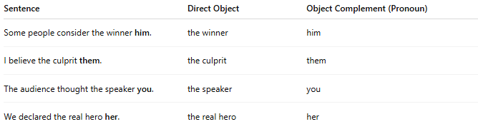
Sentence | Direct Object | Object Complement (Pronoun)
Some people consider the winner him. | the winner | him
I believe the culprit them. | the culprit | them
The audience thought the speaker you. | the speaker | you
We declared the real hero her. | the real hero | her

🔸 Important Notes:
# Source: AI Source: Provided by: [Data Path: Persons Table -> ID Column: 1, Name_En Column: Motasem Essam] -> From: [ChatGPT] on [8/4/2025]
- The pronoun and object refer to the same person or thing.
- Often sounds more informal or emphatic.
- These constructions are not always grammatically preferred in formal writing—but are grammatically valid.

🔸 Compare:
# Source: AI Source: Provided by: [Data Path: Persons Table -> ID Column: 1, Name_En Column: Motasem Essam] -> From: [ChatGPT] on [8/4/2025]
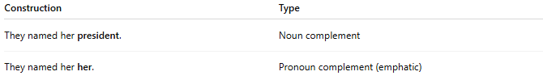
Construction | Type
They named her president. | Noun complement
They named her her. | Pronoun complement (emphatic)

